Task1:

* After add the ‘ nameserver 10.0.2.8’ entry to the /etc/resolvconf/resolv.conf.d/head file of the user machine then applied the command ‘ sudo resolvconf -u’. When I run command ‘dig www.google.com’, I got the result which indicate the server as 10.0.2.8 which is my local DNS server.
* Result:

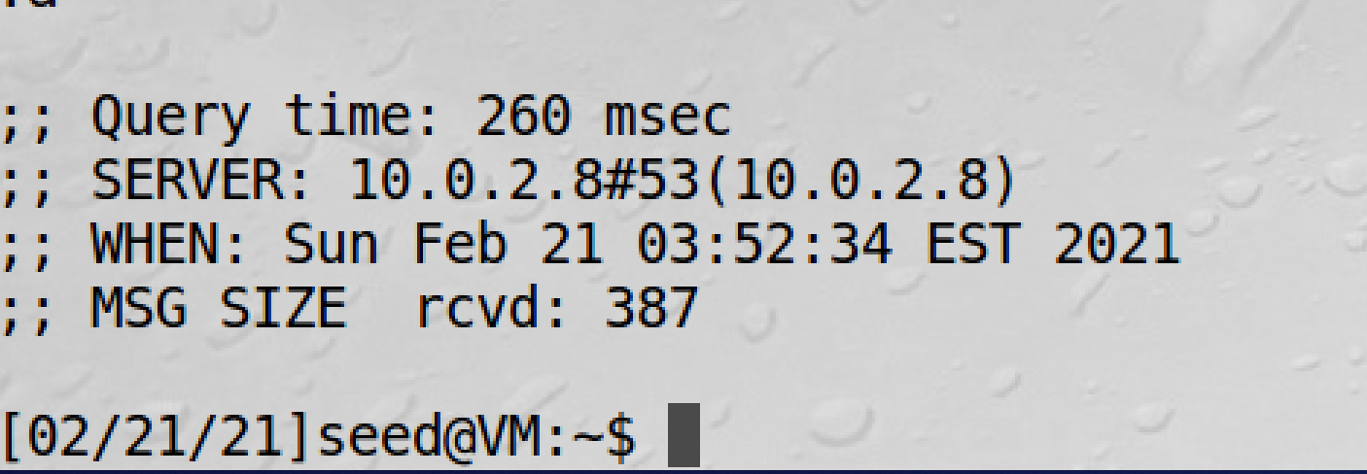

Task2:

* Based on the instruction, I set up a forward zone on the /etc/bind/named.conf file of the local DNS server machine. Under this condition, the local DNS server will not try to find IP address of the attacker32.com’s nameserver, it will just go to the attacker’s ip address which is ’10.0.2.9’. The remaining set up is already been done in the seed lab vm. After all the set up, I use command ‘sudo service bind9 restart’ to restart the DNS server.

Code:

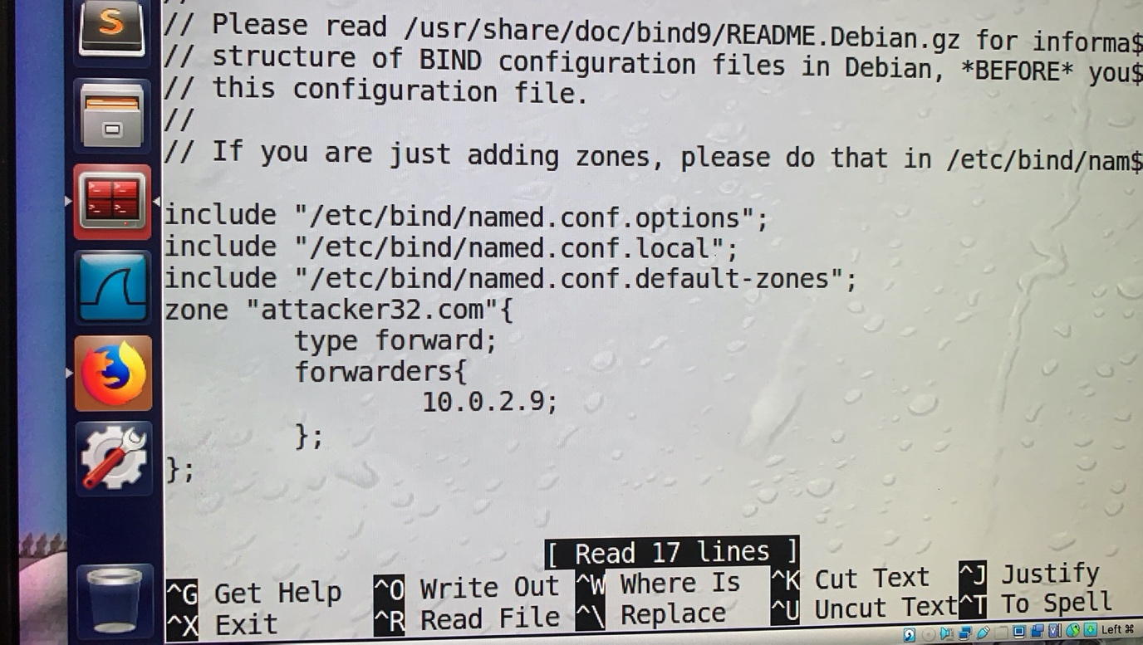

Task3:

* After I download the attacker32.com.zone and example.com.zone, I move both of them to the ‘/etc/bind’ directory. I change the all the entries of the attacker32.com.zone and ns entry of example.com.zone to the attacker’s IP address which is ‘10.0.2.9’. Then I add following entries to the ‘/etc/bind/named.conf’ file.

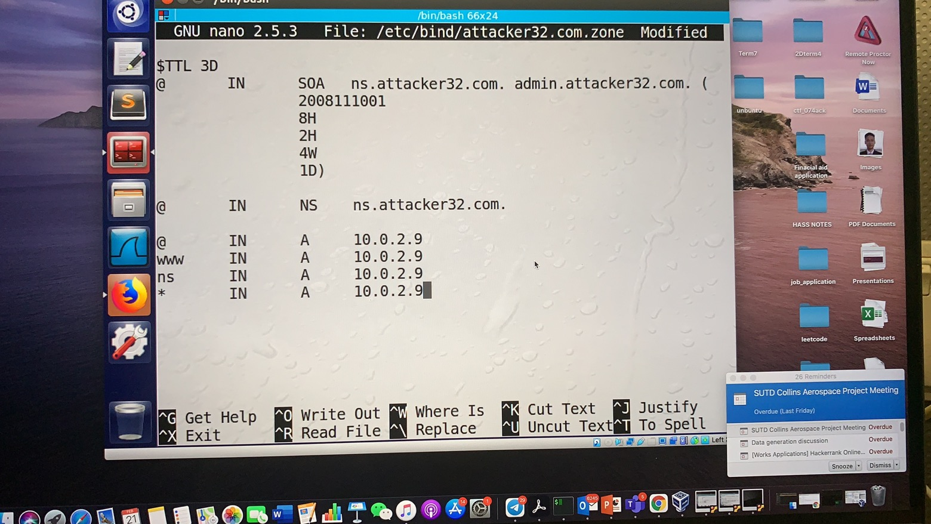

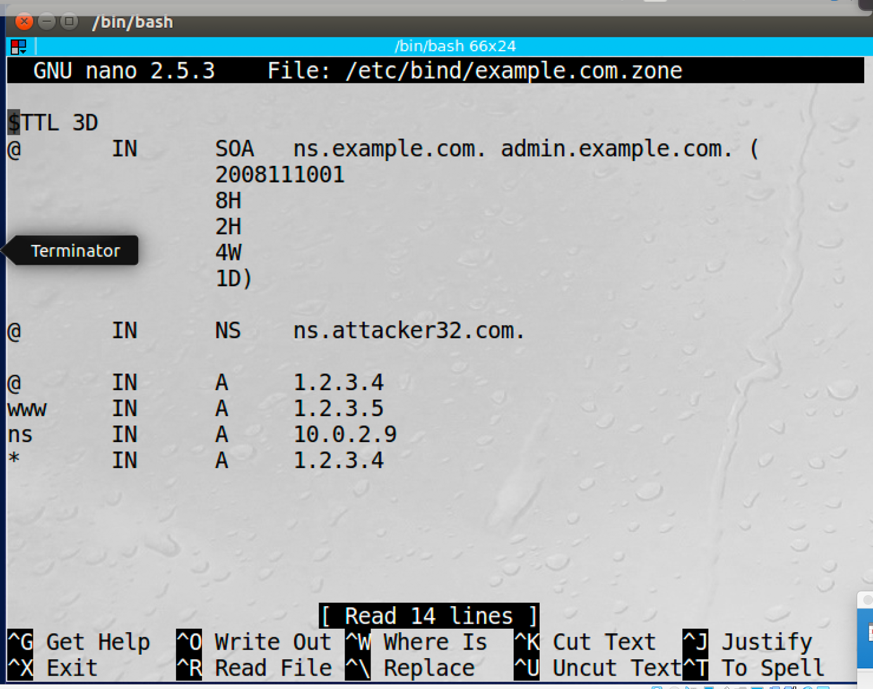

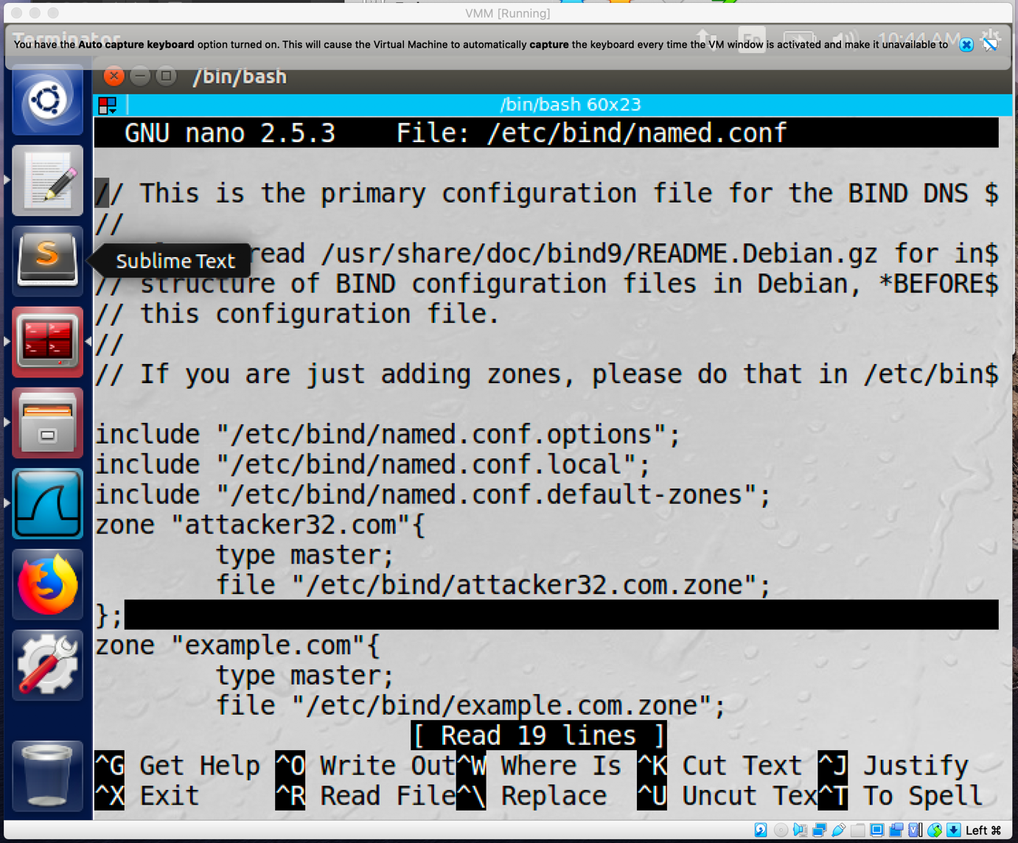

Task4:

* After I run the command ‘ dig ns.attacker32.com’ , the ip address of the ‘ns.attacker32.com’ become 10.0.2.9 since we set up the ns entry of the ‘attacker32.com.zone’ to 10.0.2.9.
* Result:

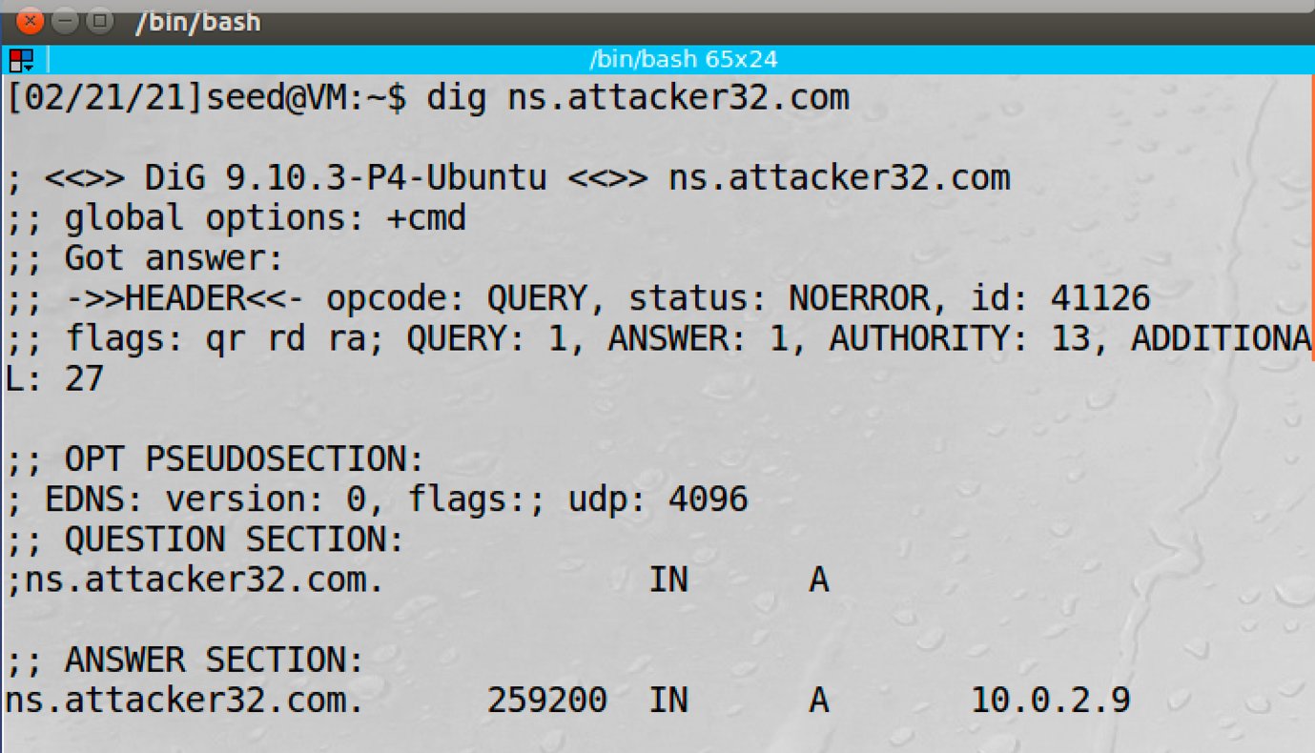

* If I direct run command ‘dig [www.example.com](http://www.example.com)’ , the Ip address of this nameserver will be its real ip address which is 93.184.216.34.

Result:

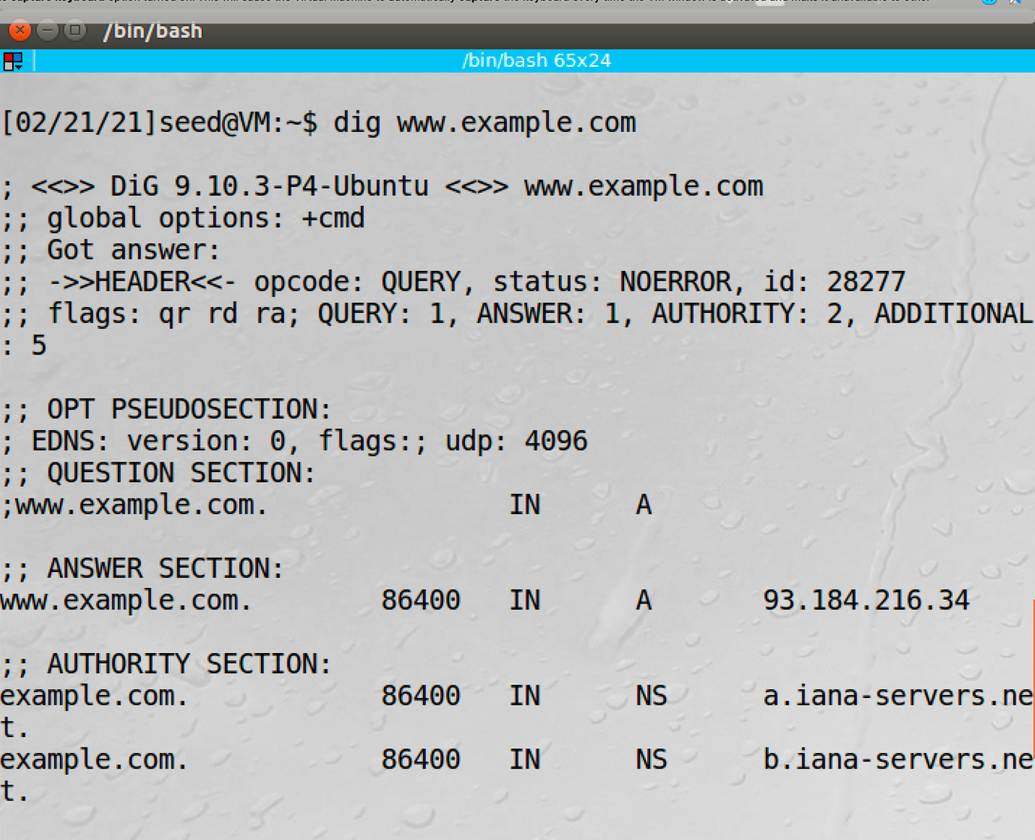

* If I run command ‘ dig @ns.attacker32.com [www.example.com](http://www.example.com)’ instead, I will get the www entry of the ‘example.com.zone’ which is 1.2.3.5.

Result:

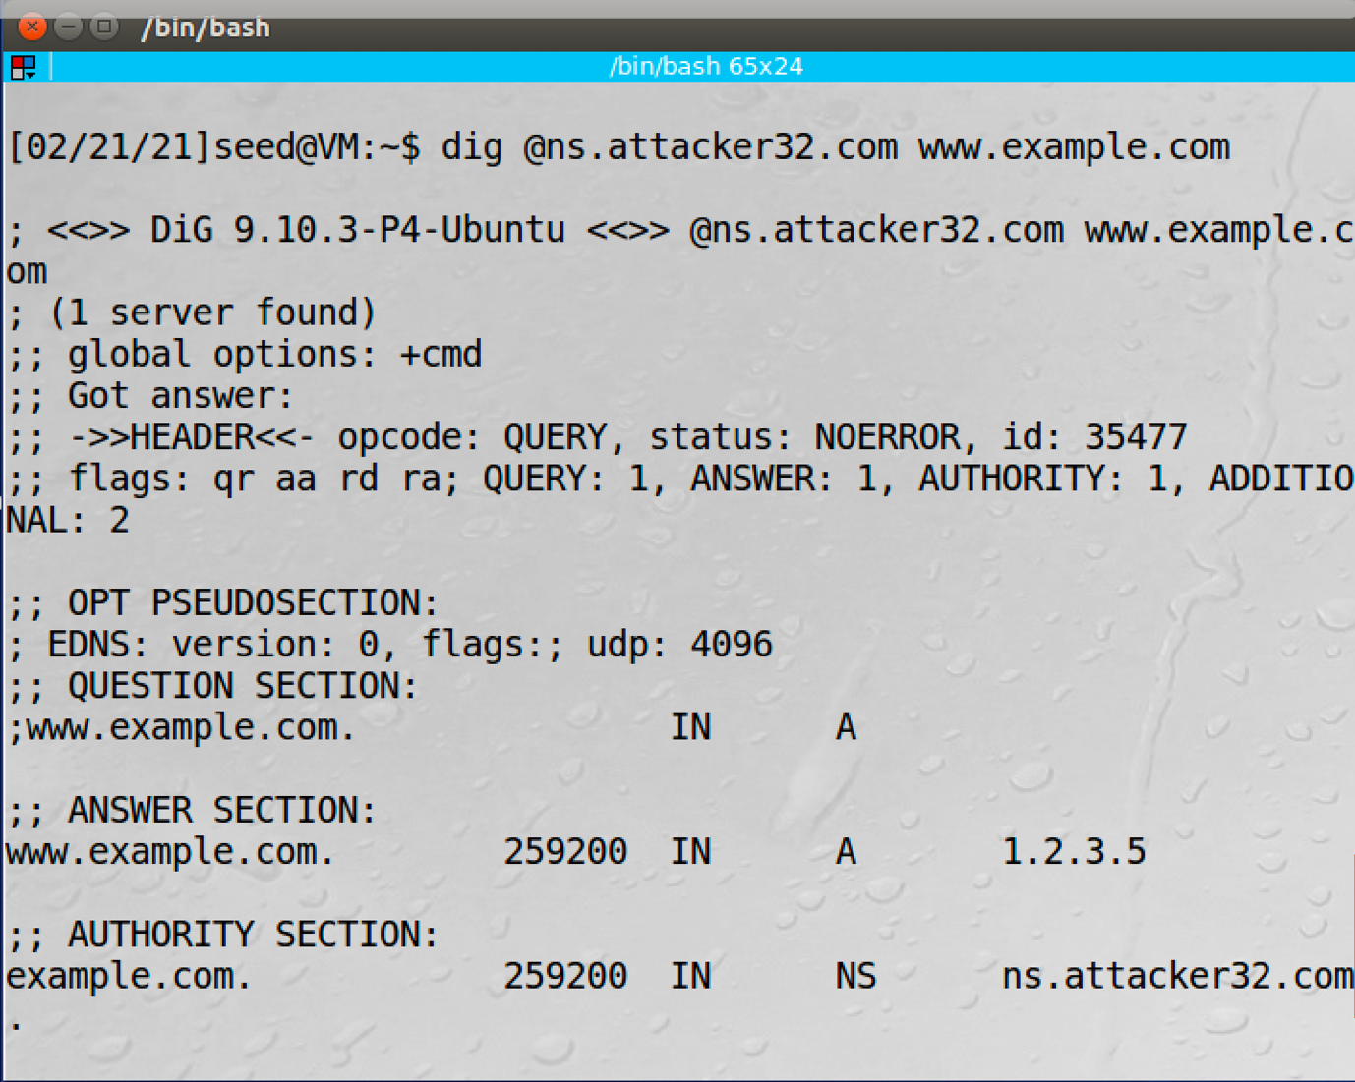

Task4:

* Code:

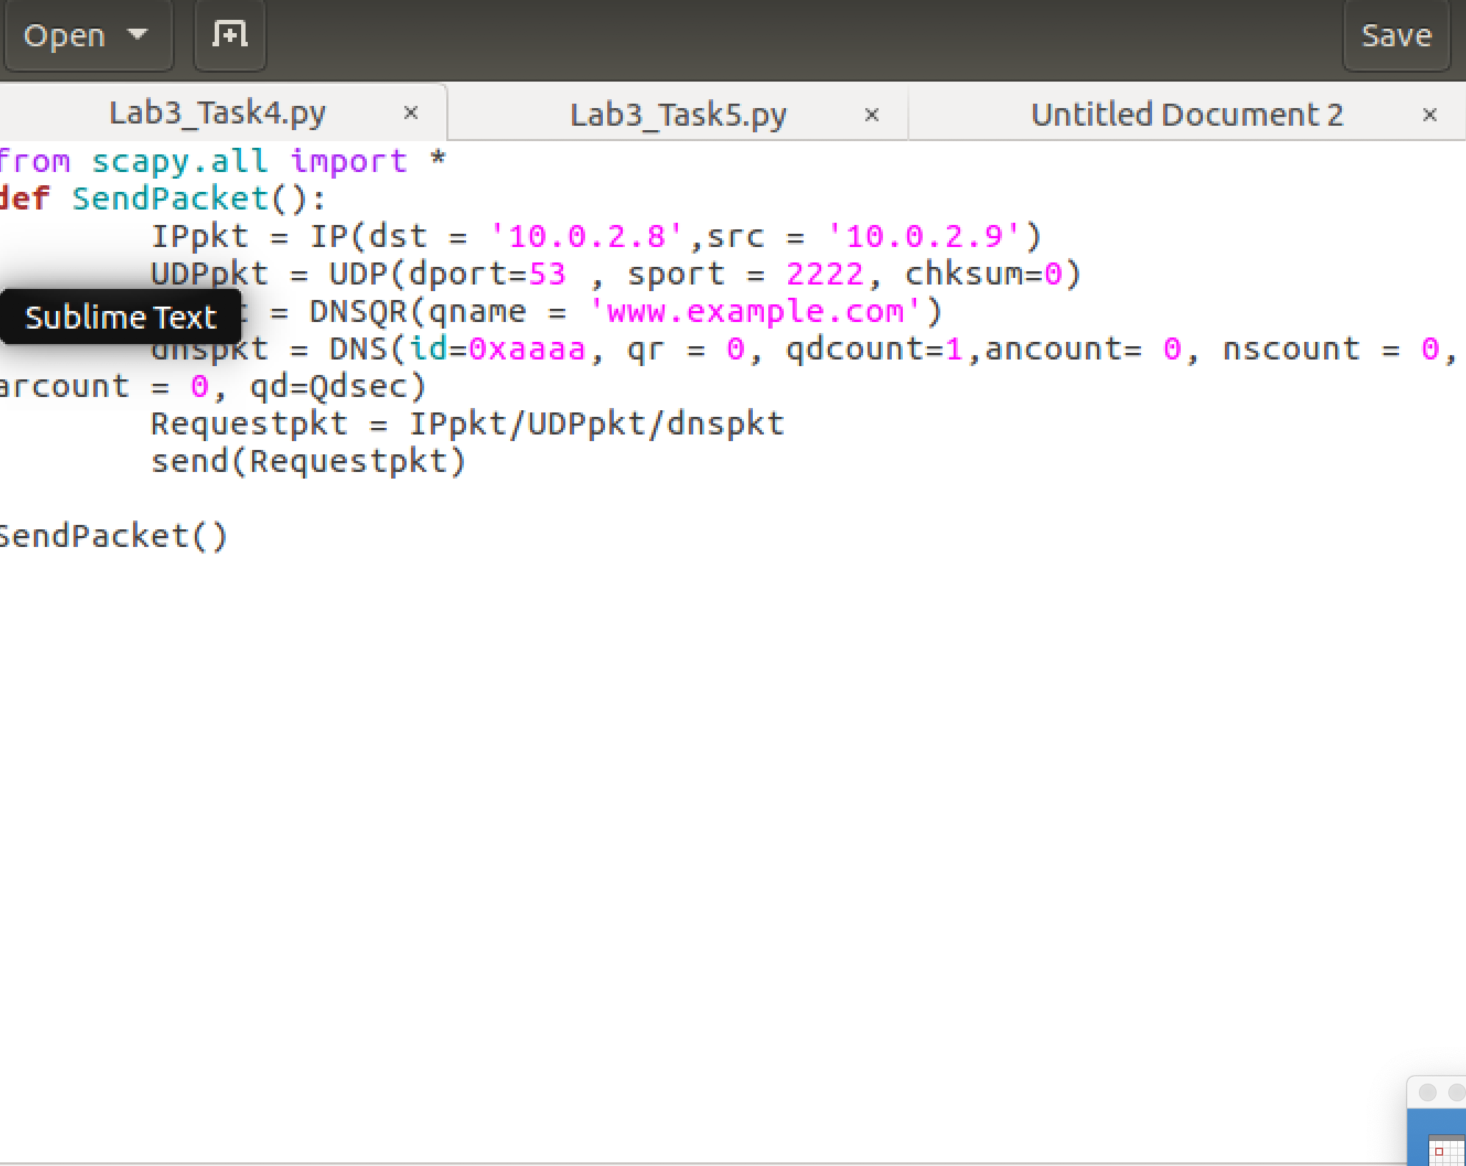

The src IP will be the attacker’s IP and the dst IP will be the DNS server’s IP.

* Result:



The packet will show port unreachable since the DNS request is fake.

Task5:

* Code:

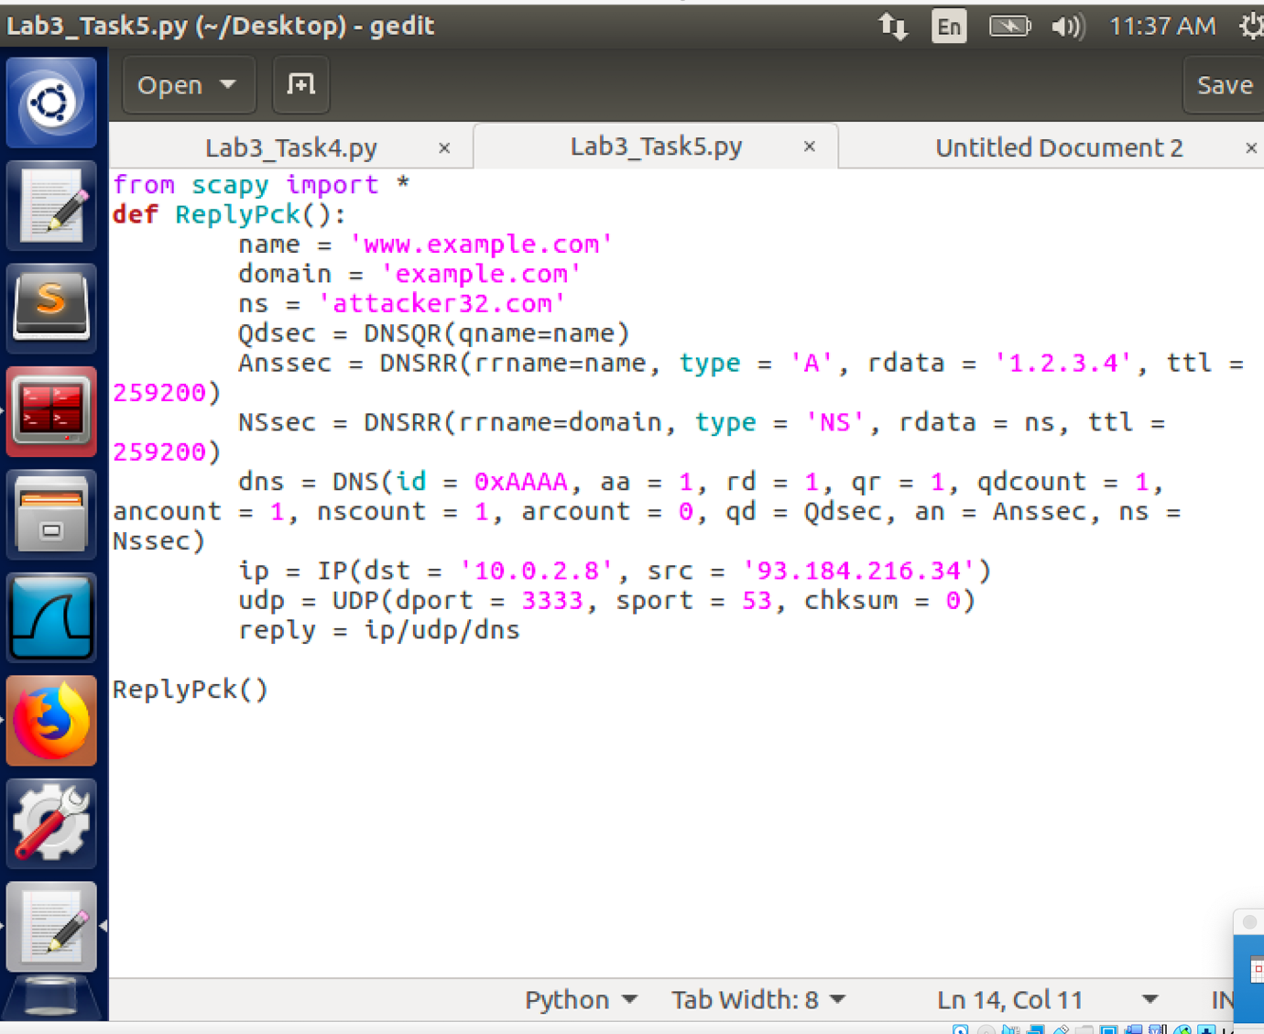

The src IP will be the real IP of the ‘www.example.com’ and the dst IP will be the local DNS server’s IP.

* Result:

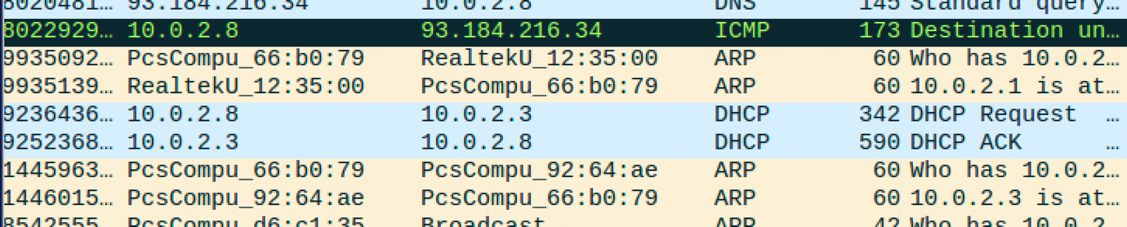

The packet will show port unreachable since the DNS reply is fake.